**ROTEM ALGORITHM**



**ROTEM GUIDELINE FOR CARDIAC SURGERY**

| **Bold – treat** |
| --- |

| *Italics – treat if bleeding/high risk of bleeding* |
| --- |

1. **When to treat CT**

| **CT in INTEM/HEPTEM > 300 sec** | **or** | **CT in INTEM/APTEM > 100 sec** |
| --- | --- | --- |
| *CT in INTEM/HEPTEM 240 - 300 sec* | *or* | *CT in INTEM/APTEM 80-100 sec* |
| CT in INTEM/HEPTEM <240 - 300 sec  (No treatment required) | or | CT in INTEM/APTEM < 80 sec  (No treatment required) |

1. **Causes of prolonged CT**

| **Test** | **Diagnosis** | **Management** |
| --- | --- | --- |
| INTEM/HEPTEM ratio >1.0 | Residual heparin | Protamine |
| FIBTEM A10 < 5 mm | Low fibrinogen | Cryoprecipitate |
| All other prolonged CT | Low coagulation | FFP 10-15 ml/kg |

1. **Clot Firmness & Management ( )**

| **CLOT FIRMNESS** | | **A10 in EXTEM/INTEM/HEPTEM/FIBTEM** | | |
| --- | --- | --- | --- | --- |
| <22 mm | 22-38 mm | ≥ 39 mm |
| **A10 IN FIBTEM** | <5 mm | **Low platelet**  **Low fibrinogen (Cryoprecipitate + Platelet)** | **Low fibrinogen**  **(Cryoprecipitate)** | *Low fibrinogen*  *(Cryoprecipitate)* |
| 5-7 mm | **Low platelet**  **Low fibrinogen (Cryoprecipitate + Platelet)** | *Low platelet*  *Low fibrinogen*  *(Cryoprecipitate + Platelet)* | Clot firmness appears satisfactory.  If bleeding consider  i) Raising fibrinogen >= 10 mm  ii) If on aspirin  consider platelets |
| ≥ 8 mm | **Low platelet**  **(Platelet)** | *Low platelet*  *(Platelet)* |

1. **Clot lysis**

| **Test** | **Diagnosis** | **Management** |
| --- | --- | --- |
| **Lysis within 20 minutes** | **Fulminant lysis** | **Tranexemic acid** |
| *Lysis between 20-40 minutes* | *Early lysis* | *Tranexemic acid* |
| Lysis > 40 minutes | Clot retraction | No treatment required |

*References:*

1. Tanaka KA, Bolliger D, Vadlamudi R, Nimmo A. Rotational thromboelastometry (ROTEM)-based coagulation management in cardiac surgery and major trauma. J Cardiothorac Vasc Anesth. 2012 Dec;26(6):1083-93

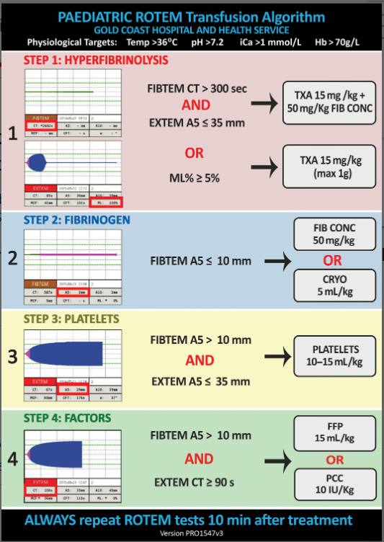

A5 based algorithm

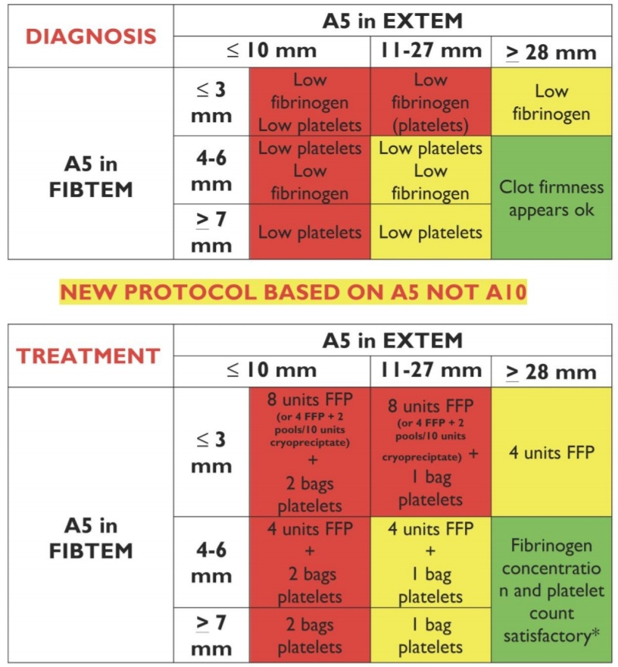

*References:*

1. George, S., Wake, E., Sweeny, A., Campbell, D. and Winearls, J. (2022), Rotational thromboelastometry in children presenting to an Australian major trauma centre: A retrospective cohort study. Emergency Medicine Australasia, 34: 590-598. <https://doi.org/10.1111/1742-6723.13939>